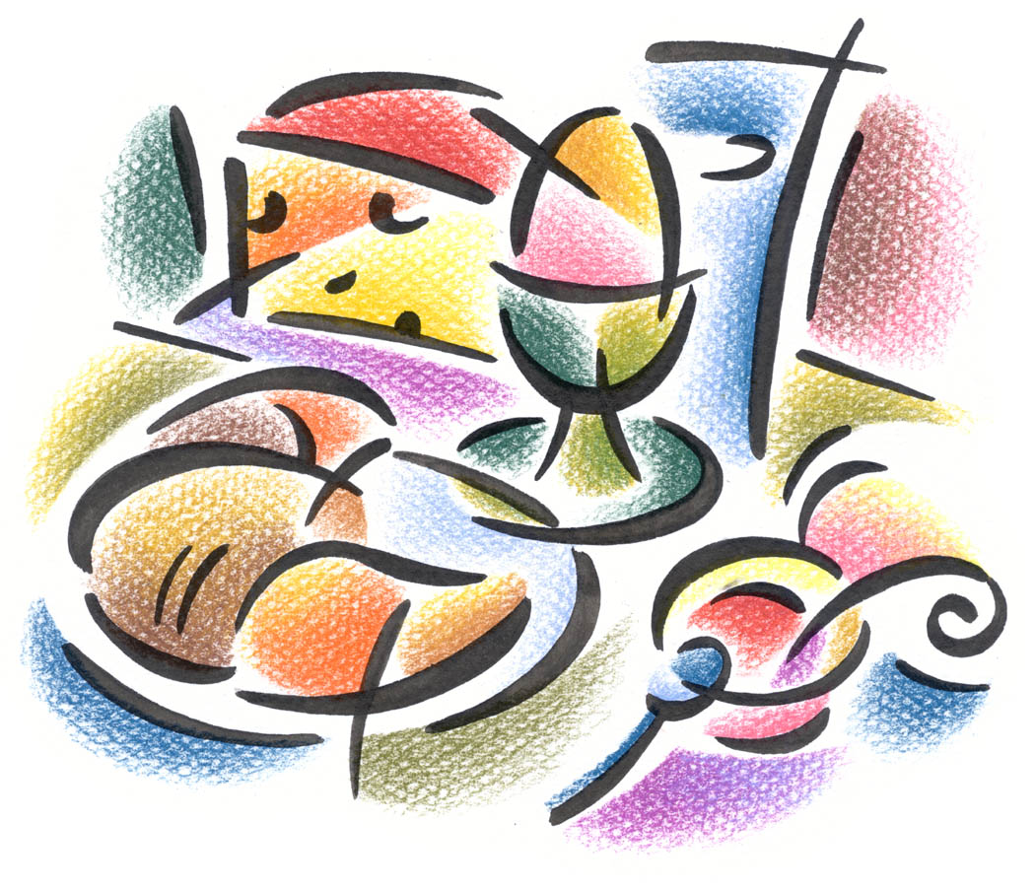
New Year’s Day

This year, New Year’s Day is on a Sunday. The Church Councils have taken the decision that there should be just one service in the Benefice that day. We shall meet, therefore, at 10.30 am at St Mary’s for informal worship which will include communion and the opportunity for us all to re-commit ourselves to God for this coming year.
After, we invite you all to the Vicarage for an early lunch. Bring something to share, and we shall enjoy fellowship and fun together.

